**Animal Movement Research Using Phase-based Trilateration**

**(AMRUPT)**

The problem

The study of animal movement has long been recognized as an important focus of behavioral ecologists. Detailed information about where and how animals move can greatly aid conservation efforts by helping ecologists to understand the effects of habitat loss on space use, the effects of climate change on migratory, breeding, or foraging behavior, and many other important research questions. Unfortunately, animal movement remains poorly studied due to a lack of fine-scale tracking technologies that are readily available for biologists.

*Localization* - A major challenge for wildlife radio tracking is in obtaining high-accuracy position data of multiple individuals in a population. Most tracking technology used today by wildlife biologists involves the use of 1-3 researchers tracking animals while on foot (or by vehicle). This approach typically results in low-accuracy position information of just a few individuals for a relatively short period of time. A far better approach would be automated tracking of multiple individuals from a network of receivers on stationary towers. Such automated systems exist – for instance the Automated Radio Telemetry System (ARTS) at Barro Colorado Island in Panama (this systems is now defunct) – but suffer from a number of setbacks. First, most existing systems use multiple antennas to create an estimate of location based on the received strength of a signal from 3 or more receiver towers. This requires bulky and expensive receiver modules, and results in fairly imprecise location data. More recent work in automated telemetry has focused on the use of GPS technology to increase position accuracy. Unfortunately, GPS technology is still far too bulky for many small organisms (including the fairywrens) and is similarly very expensive. Other efforts to create receiver networks have begun to develop the use of Time Difference of Arrival (TDOA) systems. Although these systems have great promise, they require extremely broadband signals (difficult to achieve with bare-bones transmitters), and are also limited in the degree of precision they can obtain (RF signals travel so quickly that it is highly improbable that a practical receiver network would be able to resolve animal locations to extremely fine spatial scales).

A less well-known (at least to biologists) alternative to TDOA for radio direction finding (DF) is a technique that has been used by the military for a very long time, known as Phase Interferometry for use in estimating the Angle of Arrival (AOA) of radio signals. Unlike TDOA systems, this approach does not require broadband signals, and the accuracy of AOA systems scales strongly with the spatial scale of the receiver network. For instance, 10 receivers spread over 10 square kilometers might result in location estimates of +/-200 m, whereas the same number of receivers placed over 1 square kilometer might result in an accuracy of +/-20 m. Because many researchers are interested in small-scale movements of animals within populations, such a system may be extremely useful.

AOA direction finding systems, though spatially scalable, still suffer from susceptibility to multi-path interference from RF scattering and reflections. Recent work from Dr. Edwin Kan’s group at Cornell has made extremely promising strides towards tackling this problem through the use of multiple frequencies to identify line-of-site RF signals, and reject multipath interference. His group’s work also improves the accuracy of phase-based localization by not relying on triangulation (i.e. the use of multiple estimated [and approximate] angles of arrival) but instead resolving the distance from each receiver to a transmitter using phase-integer disambiguation techniques, allowing trilateration of a location with much higher precision.

*Transmitters* - Until very recently, most wildlife telemetry devices were transmitters (i.e. they could only send information) that signaled only the animal’s identity, or very crudely encoded one or two types of information (like temperature, or activity levels). The boost in development of small, energy-efficient ICs for telecommunications has now made it possible to create radio transceivers that efficiently (and digitally) encode many types of physiological data on free-living animals and that can be given instructions remotely. Unfortunately, the majority of small radio transmitters on the market today are still far too large for use with animals like fairy-wrens. Without small, energy-efficient transmitters, the receiver network cannot be put to use for small bodied animal species.

Technical specifications:

The AMRUPT project seeks to combine features from existing phase-based RF localization technologies (such as the one developed by Dr. Kan’s research group) and ultra-miniature wildlife transmitters to make a scalable, accurate, and low-cost wildlife radio direction finding system. The following is a list (not exhaustive) of specifications for the functionality of the AMRUPT receiver network:

1. Short range communication with mobile nodes (i.e. wildlife tags) is sufficient (*100-300 m between receivers*)
2. Extremely simple transmitter design (*lightweight [150 – 350 mg], low power, not broadband*)
3. The system can operate in cluttered environments (*multipath interference from tree trunks and leaves is not a significant problem*)
4. System can operate with ~50 Txers
5. High spatial accuracy (~5 m) triangulation/trilateration
6. Low cost receivers (*COTS components, no ASICs or expensive DSP chips*)
7. Low power consumption of receivers (*solar-powered or charging possible*)

The AMRUPT telemetry system  
There are two primary aspects of the telemetry system that we are developing in the hopes of studying the social behavior of red-backed fairywrens, little hermits, and Florida scrubjays: 1) an automated phase-based trilaterating receiver network and 2) light-weight radio transmitters capable of transmitting an ID (and potentially other data) when prompted to do so.

1) The receiver network:

*Phase 1*: The basic premise of the system’s function in the first phase of development is that a series of base stations (ground-nodes) will use two to four evenly spaced dipole antennas to receive and analyze phase differences in received signals that are transmitted from on-animal radiotags (mobile-nodes). AOA estimates from multiple ground-nodes can then be used to triangulate mobile-node locations.

*Phase 2*: In the second phase, the accuracy of RF phase differences will be refined through the use of multi-frequency mobile-node transmissions, and the subsequent selection of frequencies that are not contaminated by multipath interference. Triangulation accuracy may be notably improved through this process.

*Phase 3*: The final phase is the estimation of a precise distance of each mobile-node from each ground-node within range via a multi-frequency phase-integer disambiguation algorithm. The estimated distances from different ground-nodes will be used to trilaterate mobile-node location, likely further improving position accuracy.

*Architecture:* Each receiver will likely include at least two antennas, a low-noise RF amplification stage, either 1) a mixer, demodulator, and ADC unit, or 2) a transceiver chip capable of serving these functions, and a DSP (see Figures 1 and 2, respectively). The vast majority of the effort will be concentrated on the direction-finding and datalogging architecture.

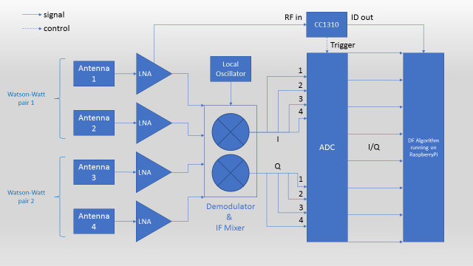

Figure 1: Receiver architecture with antennas, LNA, Mixer/Demodulator, ADC, and DSP.

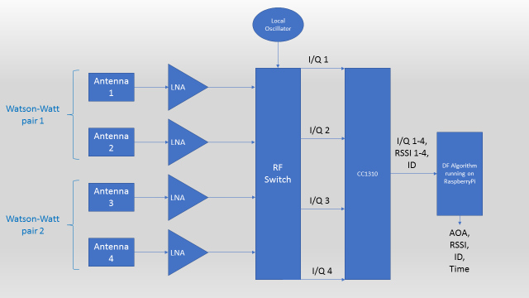Figure 2: Receiver architecture with antennas, LNA, RF switch, RF transceiver (CC1310), and DSP.

2) The transmitters:

*Phase 1:* The first goal for the transmission-side of the fairywren telemetry project is to create a small, energy efficient radio tag capable of communicating with the receiver network. Although this may sound like a relatively simple task, the constraints on the final weight of the tag – 350 mg – will make this a deceptively challenging task. Because the tags must be extremely small, we will have to consider the possibility of energy-harvesting solutions to extend battery life. RF packets from mobile-nodes will need to transmit at low carrier frequencies (~150 MHz) since low frequencies transmit better through the environment, especially in the presence of vegetation.  
*Phase 2:* Once we have a working “beeper tag” the next step is to add in the ability to transmit other forms of data received by various sensors that are integrated into the tag, while staying below the 350 mg weight budget. Because transmitting physiological data will require that the transceiver IC be in active mode (very energetically expensive) it will be important that the tags transmit such data only when the receiving transceiver is within range (meaning the tag must be able to listen for a targeted wake-up command from it), at the right times.   
*Architecture:* The mobile nodes will likely consist of an energy-harvesting solution, a transceiver chip (CC1310), and some form of storage element. In later iterations we may begin adding in I2C-compatible sensors.

About me:  
I am a postdoctoral researcher in animal behavior at Cornell, based at the Lab of Ornithology, and, as you know, I am directing a design project involving the development of an automated telemetry system for tracking small free-living animals. For my graduate work at Cornell in the department of Neurobiology and Behavior I studied the breeding behavior of an extremely small hummingbird (the little hermit) on the island nation of Trinidad. As part of my research it was important that I locate the nests of these birds, however, because these nests are extremely difficult to locate visually I had to find a way to find nests using other means. Telemetry (i.e. tracking animals fitted with radio transmitters) appeared to be an attractive solution, but no radiotransmitters were commercially available that were small enough to be carried by the birds (the US government stipulates that no device can be fitted on a wild bird that exceeds 5% of the weight of that bird, in this case a 150 mg tag would be required). If I wanted to track these birds I would have to make these radiotags myself. Because I had only a background in biology, not engineering, I had to spend a good deal of time learning much of the basics of radio electronics, but I was ultimately able to create tags that worked for this purpose. See the picture of a little hermit fitted with one of these radiotags below:

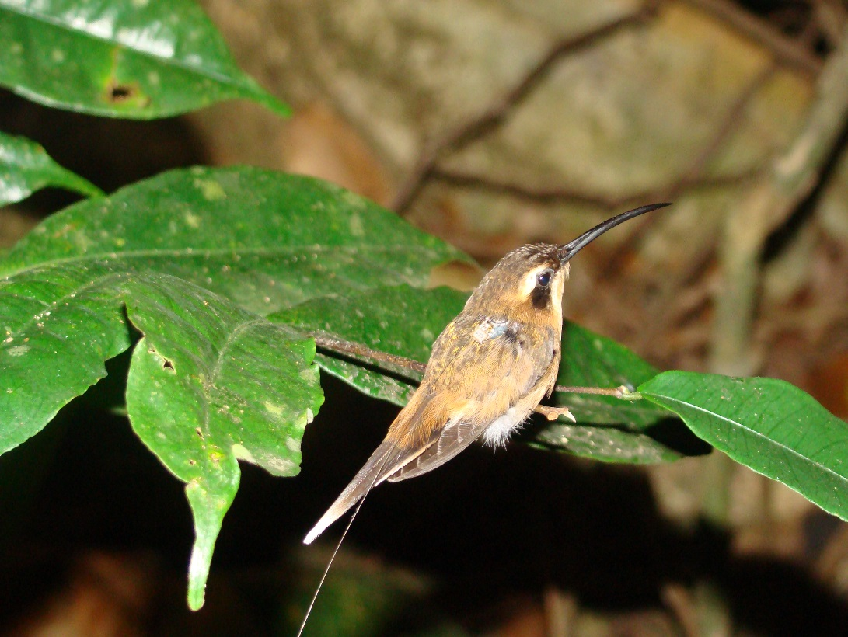

Since completing my graduate work I have moved on to a postdoctoral position at the Lab of Ornithology, where I am conducting a study on a small Australian bird (the red-backed fairywren), which is only slightly larger than the little hermit (~7 g). These birds are interesting, in part, because males of this species spend much of their lives as dull-colored individuals (see the picture below, photo credit T. Ashton) with low chances of obtaining a mate, but when they molt into bright plumage (the black individual with red feathers) their reproductive success drastically improves. The curious thing about this situation is that the timing of this molt in the non-breeding season (i.e. how early in the year the male begins to transition from dull to bright) predicts how well males do later during the breeding season in a different fairywren species, and likely in this one as well. Males go around during the non-breeding season showing off their plumage and singing to females. What this means is that females must be paying attention to which males molt early, and remembering who these males are. The goal of my postdoctoral project is to understand how females identify individual males in the pre-breeding season. Unfortunately, following these birds is extremely difficult since they are very mobile, and recording their songs is even more challenging because they are wary of researchers who approach close enough to record them.

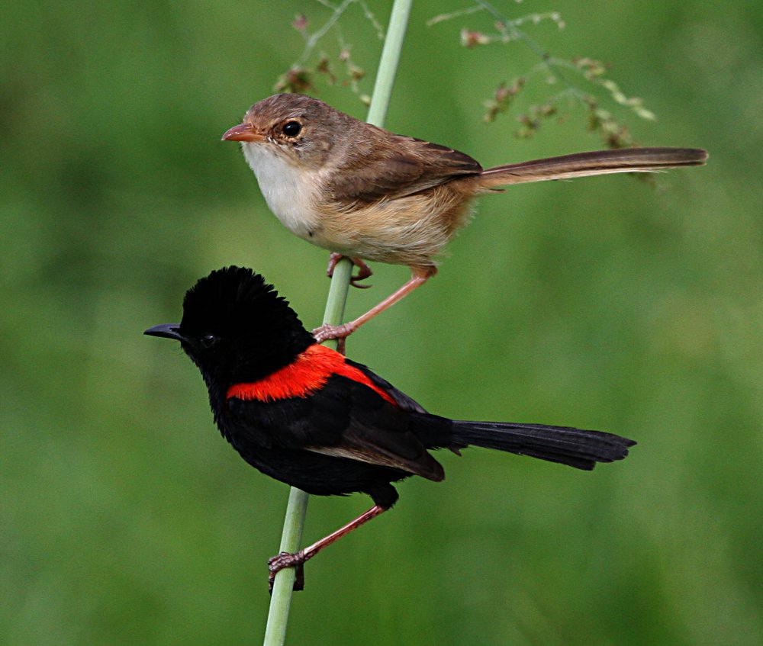

Both of these technical difficulties could potentially be resolved with telemetry technology, so I am continuing to develop my transmitters for use with these birds. Although I have a clear vision of the type of telemetry system I would like to deploy to study these birds in Australia, I have reached the limit of my understanding of telemetry technology; which is why I am seeking smart, motivated engineering students to help me to continue developing an appropriate telemetry system.